THE AMERICAN SOCIETY FOR CELL BIOLOGY
2015 ASCB ANNUAL MEETING – SAN DIEGO

INSTRUCTIONS DESIGNATING ABSTRACTS FOR POSTER SESSIONS

ASCB Abstract Program Committee Meeting Preliminary Information
Please note:
- Abstracts selected for Minisymposia and Microsymposia (formerly ePoster Talks) have already been pulled and programmed. The day and time for minisymposia have been determined by the Program Chair. The day and time for ePoster Talks will be determined in late September.
- All other abstracts accepted will be programmed in poster sessions by you.
- Abstracts are sorted by topic categories and subcategories. You can view the topics and subtopics, as well as the total number of abstract submitted to each subtopic on the google document located here: https://docs.google.com/spreadsheets/d/1wfbti_fBPhGUUizcuCJCcx0nkldfgljfuQ83bUZ9KzM/edit?usp=sharing
- You are invited to select topics you wish to review by adding your initials next to the topic on the google document and downloading the PDF of abstracts associated with that topic from the abstract review website (First step of step-by-step review below).

Background Information
Authors were asked to indicate their first and second choices for poster topic placement. They are arranged in the review system by primary topic. If you think an abstract has been placed in the wrong subtopic, you may put the abstract into an author’s second subtopic choice or into the category you feel is most appropriate.
- There are 1722 abstracts to be assigned to poster sessions for this meeting. Approximately 574 regular posters will be presented on Sunday, Monday, and Tuesday (more will be added after the October 14 deadline.
- If possible, no fewer than 10, or more than 25, abstracts should be assigned per poster session.
- If more than one session is needed for a large number of abstracts (i.e., 25 or more), you should distribute the abstracts into the number of sessions required to accommodate the abstracts (i.e., ACTIN I, ACTIN II, ACTIN III). The sessions will then be scheduled on two or three meeting days. Abstracts do not have to be divided evenly into the sessions; focus on dividing them by topic.
- In the case there are more than 75 abstracts submitted for a particular topic, please divide the number of abstracts submitted by 3 and schedule approximately that many abstracts per session.
- Please note: We have received many requests in recent years to schedule posters of similar topics within a poster session together. We ask that you please take the extra time to make our poster sessions more user-friendly to the attendees by sorting them (STEP #12) after you have assigned them into sessions.
- Prior to beginning the review, please note the main topic categories are referred to as “Parent Topics” in the review system and the specific subtopics are referred to as “Child Topics.”
Review Guidelines
The ASCB invites the submission of abstracts that report new scientific research developments in all areas of cell biology. Abstracts are welcome from scientists and students in all sectors, including academia, government, industry, and education.

You should read abstracts for:

Promotion of Commercial Product
Abstracts that may be promoting a commercial product (that is, abstracts that don’t present new data, not simply abstracts from industry scientists; the latter are acceptable), should be “flagged” and brought to staff attention. (Individuals who would like to promote a particular commercial product or service are encouraged to participate in the meeting as an Exhibitor.)

Relevance
Abstracts outside of cell biology (we use a very broad definition for cell biology) should be “flagged.”

Quality
Abstracts that do not meet the minimum standard for responsible research should be “flagged.”

Rejection Guidelines
If you flag an abstract for any of the above reasons – deeming it unsuitable for presentation at the Annual Meeting – you will need to provide a detailed explanation regarding why it is rejected. Before you fill out the form, allow another member on the committee to read it to ensure they agree. All flagged abstracts will be forwarded to the Program Committee Chair, who will make the final decisions.

Request from the ASCB’s Public Information Committee (PIC)
The PIC “peer screens" abstracts submitted for minisymp presentation at the first deadline looking for science news. This year they screened 1242 abstracts, looking to get down to a top 10 (or top 15). We decided that we might be missing good news stories coming in at the later deadlines. However, on this shorter deadline, we need your help to pre-peer screen these later submissions and get down to a smaller number—say around 20—that PIC will consider adding to the package of press releases that we promote to the news media at the Annual Meeting.

So what’s peer screening? First and foremost, we’re looking for NEWS. An obvious health/disease angle is a powerful pull for the media but not every cancer abstract is newsworthy. Also important science can speak for itself (especially with a little help from us). Beyond the Big Discoveries, you were also looking for abstracts that touch on “cool science,” a finding that's interesting or cool enough to explain at a Memorial Day picnic to your brother-in-law, a member of Congress, or someone with that disease/problem. You will find many scientifically interesting abstracts that do NOT meet these criteria.

Please see the next page for step-by-step instructions on how to use our new online review system.

STEP-BY-STEP REVIEW INSTRUCTIONS WITH SCREENSHOTS

- Visit the google document available in your google drive to place your initials next to the topic you are going to review. If you cannot access the google drive document, please tell an ASCB staff member to add your initials for you prior to continuing with the review. You will need to repeat this step each time you begin a new topic to avoid duplication. Please select topics with less than 7 abstracts first so they can be re-assigned earlier in the process.

- Visit http://abstracts.ascb.org/Portal and login using your ASCB Login information. If you do not know your login information, please ask ASCB Staff to assist you.

- Once you have logged in, please ensure you are on the Review tab (which looks like Figure 1 below). If you are not on the review tab, click on “Review” at the top of the page and select “My Dashboard”

- After you are on the Review page, you will see the list of submission topics (see blue arrow in Figure 1 below), under a header of “Batch Download Submissions by Topic (as PDF).” Click on the topic you just initialed in the Google Document (see step 1), which will download a PDF of the abstracts submitted to that topic.
Figure 1
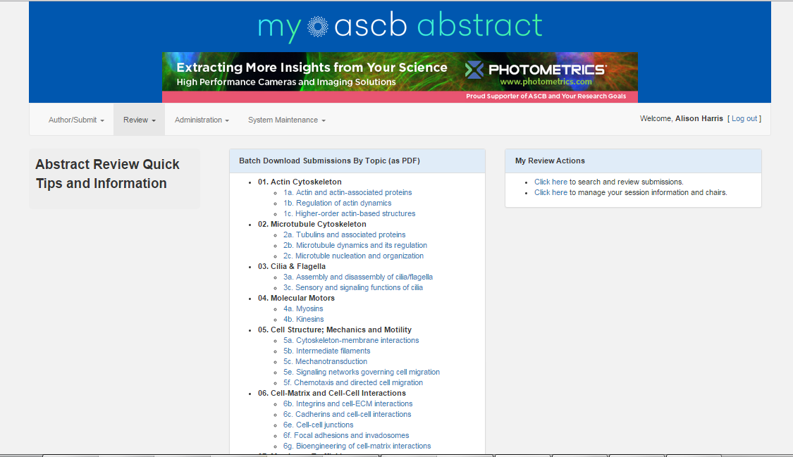

- Review the abstracts for your selected topic. You can use the blank paper on the table to make notes about certain groupings or submissions.

- Once you read through the abstracts, click on “Click here to search and review submissions” under the “My Review Actions” section on the right of the screen (See green arrow in Figure 1 above). You will now see the screen in Figure 2 on the next page.
Figure 2
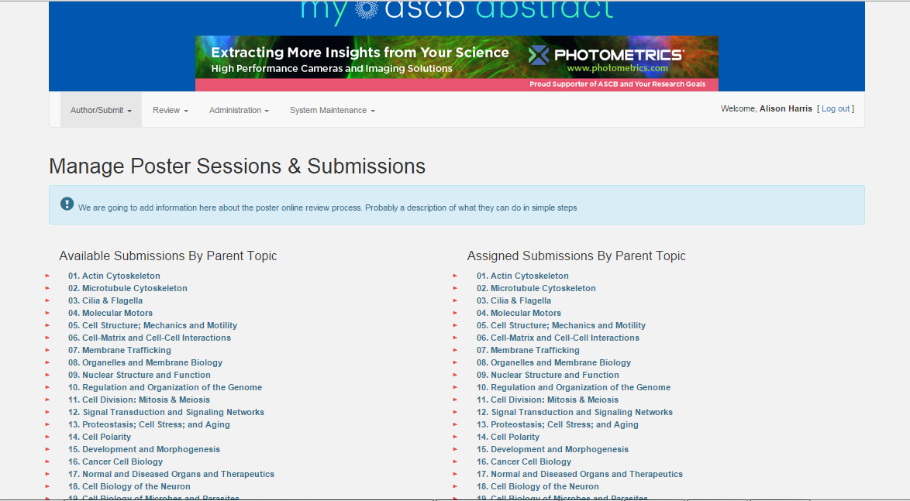

- Click on the Primary Topic (“ Parent” topic) for the abstracts you are reviewing in the first column, “Available Submissions by Parent Topic” and it will open a list of the Subtopics (“Child“ Topics). See Figure 3 below.
Figure 3
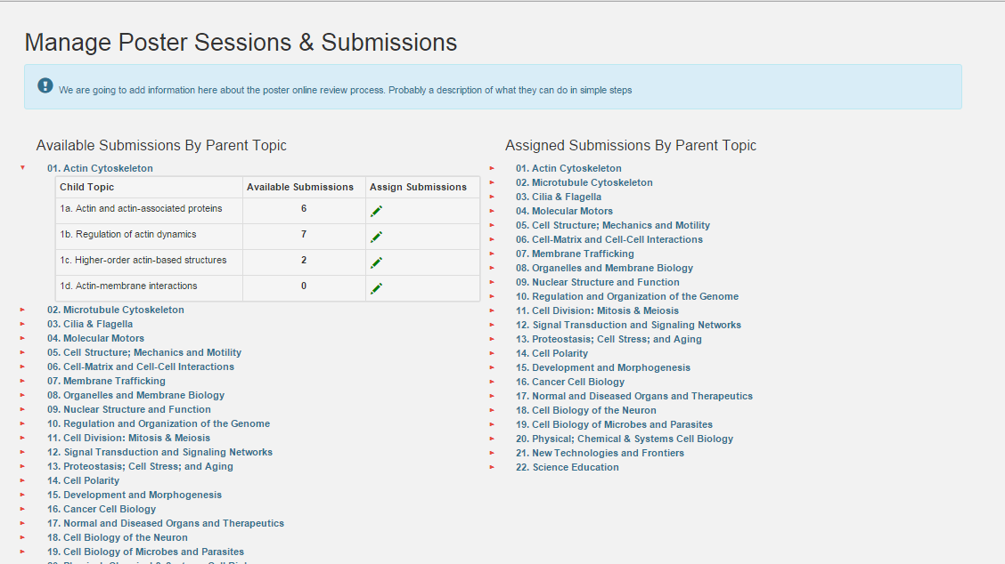

- Click the green pencil under the “Assign Submissions” column that corresponds to the topic you are reviewing (and initialed in the google document). Once you do this, you will see the screen in Figure 4.

Figure 4
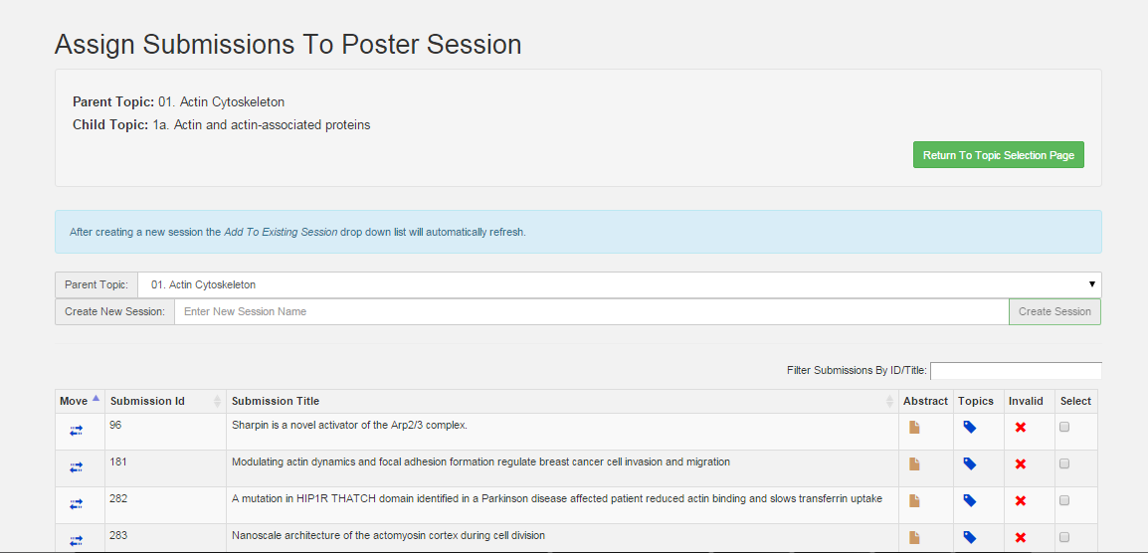

- Rejecting Abstracts.
If you do not have any abstracts to reject in the topic you are reviewing, skip this step and move onto Step 10.
If you have any abstracts that need to be rejected. Please confirm with one other committee member and then click the red X under the “Invalid” column. Once any rejected abstracts have been removed from the list, move on to step 10.

- Creating Sessions and Entering Session Titles.
You will need to first add the title(s) of the session(s) before you can assign abstracts to them. To create a session:
  - Enter the title for your session where it says “Create New Session” (See blue arrow in Figure 4 above). You can use the same current Child topic title (see purple arrow in figure 4 above) for the title or rename it if you see fit.
  - Once you type in the title, the “Create Session” button will turn from grey to green which indicates it is now active. Click “Create Session.”
  - If you have more than one session for the topic you are reviewing, continue steps (a) and (b) until all session titles have been created. Reminder: There can only be up to 3 sessions for any child topic.

- Assigning abstracts to the Sessions.
After you have created the sessions, you will assign the abstracts.
- Use the drop down on the “Add to Existing Session” section to select the session you wish to assign the abstracts to (See blue arrow in Figure 5 below).
- Click the boxes under the “Select” column (see green arrow in figure 5 below) to accept all of the abstracts you want for the session.
- Click “Save Selections” (blue button) at the bottom right of the page after you have done steps (a) and (b). You will notice the abstracts you selected will be removed from the list.
- Continue this process until all abstracts have been assigned to the session(s) you create.
- If you have abstracts that need to be re-assigned, skip to step 12 for instructions before completing step 11f.
- Once you have finished, click the green “Return to Topic Selection Page”

Figure 5
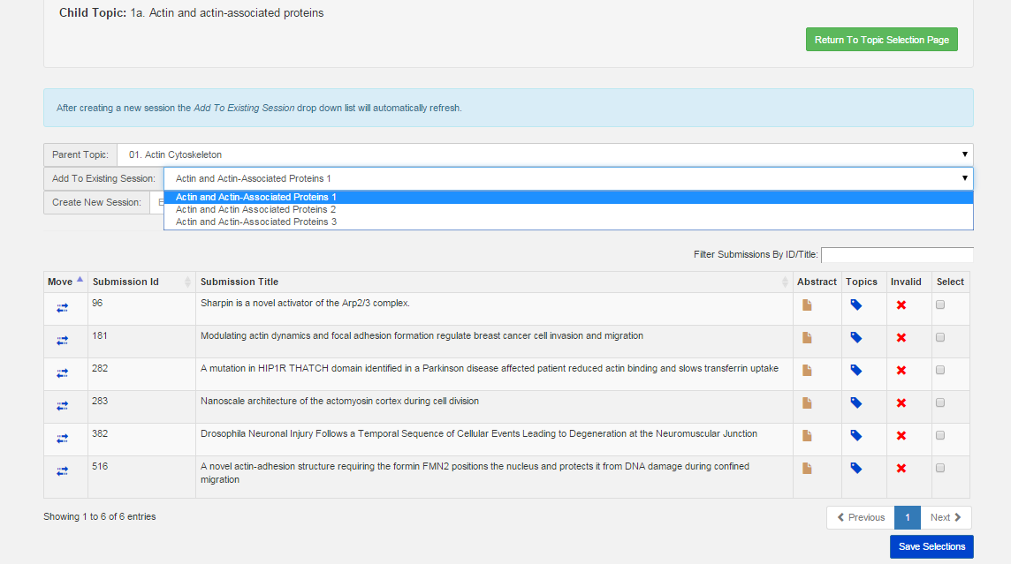

- Moving abstracts from one topic to another (IF NEEDED, otherwise Skip to Step 13)
If one or more of the abstracts in your subtopic needs to be moved to another topic, please follow these instructions.
- Check to see if a topic you would like to move has already been created by selecting the appropriate main (Parent) topic using the drop down menu (see blue arrow in Figure 6). If the option “Add to Existing Session” appears (see the green arrow in Figure 6 below), search through the topics in the drop down menu. If “Add to Existing Session” does not appear, the subtopic is not already created, so move on to step (b). If the appropriate session title is already listed as a session, follow these instructions:
    - Select the appropriate topic from the drop-down menu “Add to Existing Session.” (See purple arrow in Figure 6).
    - Check the box next to the abstract(s) you wish to move (under the “Select” column).
    - Click the blue button, “Save Selections.” The abstract(s) will then be removed from your list and moved to the session selected.

Figure 6

- If the subtopic/session you are looking for as not been created, follow these instructions:
    - Click the blue arrows under the first column titled, “Move” next to the submission ID of the abstract you wish to move.
    - A pop up box will appear (see Figure 7 below) and you will need to select the main (Parent) and subtopic (Child) you want to move the abstract to.
- Once you select the Parent and Child topics, click “Move” and the abstract will be removed from your list and moved to the other topic.
- Repeat this process for all abstracts you wish to move.
- Once you are finished, click the green button “Return to Topic Selection Page,” and you will be taken back to the “Manage Poster Sessions & Submissions Page” in Figure 8 below.

Figure 7

Figure 8

- Arranging Abstracts in Order, Removing Abstracts from Assigned Sessions, and Deleting Sessions
The next step involves arranging the abstracts in a logical order within the session to ensure abstracts with similar topics are presented near each other during the poster sessions. We are now working with the column on the right.
  - Under the “Assigned Submissions by Parent Topic Column” on the right, click on the Main (“Parent”) topic.
  - A grid with all of the sessions created under the selected parent topic will appear (see blue arrow in Figure 9 below). To edit the session, click on the paperclip under the column “View Submission.”
  - You can hover over the double arrows under the “Order” column to drag and drop the submissions into the order you prefer (See blue arrow in Figure 10 on the next page).
  - Once you have them in the order you would like, click “Return to Topic Selection Page” and your new order will be saved.
  - If you created a session by accident, you can click on the red “X” next to the session in the “Delete Session” column. This will return any abstracts in the session back to their unassigned status in their primary topic categories on the left column “Available Submissions by Parent Topic”.

Figure 9
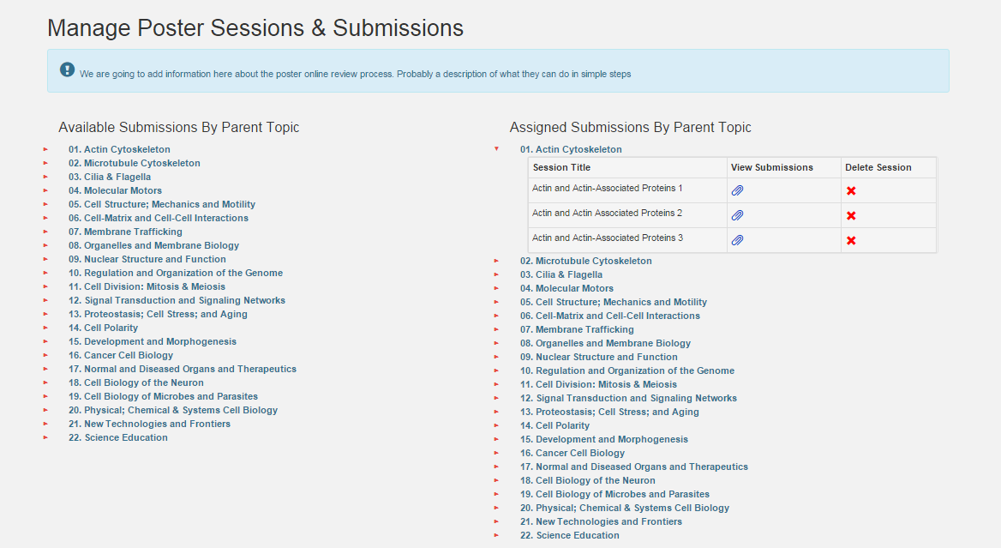

Figure 10
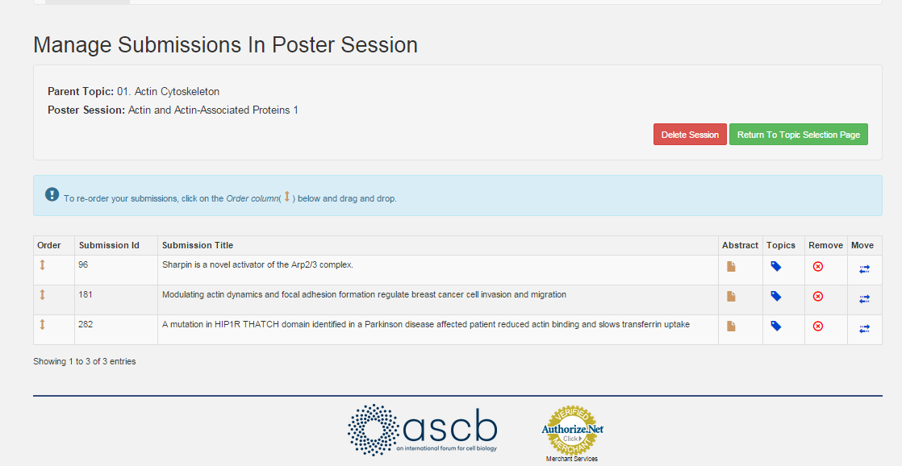

- Continue steps 1 through 12 until all abstracts are moved from the “Available Submissions by Parent Topic” to the “Assigned Submissions by Parent Topic,” and all topics on the Google Document have initials next to them.

Please note: If there is an existing topic in use by someone else when you try to view the available submissions for a topic, you will be notified of this. If for some reason a topic is locked but nobody is working in it, please notify ASCB Staff so we can unlock the topic.

